Experiment No. 1
Problem Statement:
Write a program for error detecting code using CRC-CCITT (16-bits).

Theory:
It does error checking via polynomial division. In general, a bit string can be represented using a polynomial. Ex: 10010101110 can be represented as X¹⁰ + X⁷ + X⁵ + X³ + X² + X. All computations are done in modulo 2. The algorithm uses G(x) = X¹⁶+X¹²+X⁵ +1 as the generator polynomial which used in HDLC, X.25, V.41, XMODEM, Bluetooth, SD and many others.
Algorithm:
- Given a bit string, append 0S to the end of it (the number of 0s is the same as the degree of the generator polynomial) . Let B(x) be the polynomial corresponding to B.
- Divide B(x) by some agreed on polynomial G(x) (generator polynomial) and determine the remainder R(x). This division is to be done using Modulo 2 Division.
- Define T(x) = B(x) –R(x), (T(x)/G(x) => remainder 0)
- Transmit T, the bit string corresponding to T(x).
- Let T’ represent the bit stream the receiver gets and T’(x) the associated polynomial. The receiver divides T’(x) by G(x). If there is a 0 remainder, the receiver concludes T = T’ and no error occurred otherwise, the receiver concludes an error occurred and requires a retransmission.

The algorithm can be implemented using a feedback shift-register as shown below.
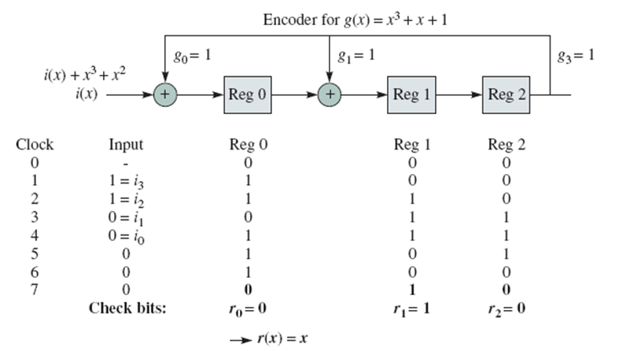

/**************************************************************************
* File Name : crc.c
*
* Description :Program for error detecting code using CRC-CCITT (16-bits).
***************************************************************************/

#include<stdio.h>

#define MAX_SIZE 20

//this strcuture 16 bit CRC
struct reg
{
int bit;
}r[16];

int n; // no. of input bits
int input[MAX_SIZE];

// function to implement the encoder for CCITT-16 polynomial

void compute_crc()
{
int i,j;
int lmb; //corresponds to right most bit of the shiftt-register circuit.

for(j=0;j<(n+16);j++)
{
lmb=r[15].bit;

// shift the bits
for(i=15;i>0;i--)
{
r[i].bit=r[i-1].bit;
}

r[0].bit=input[j];

//if leftmost bit is 1 , XOR the Dividend and Divisor.
//you can make your program portable by avoiding ^ operator
if(lmb==1)
{
r[12].bit = r[12].bit ^ lmb;
r[5].bit = r[5].bit ^ lmb;
r[0].bit = r[0].bit ^ lmb;
}
}
printf("Register content:\n");

for(i=15;i>=0;i--)
printf("%d ",r[i].bit);

for(i=n,j=15;j>=0;i++,j--)
input[i]=r[j].bit;
}

// function to check error in the transmitted data

int check_err()
{
int i;

for(i=15;i>=0;i--)
{
if(r[i].bit != 0)
{
return i;
}
}
return 0;
}

void read_input()
{
int i;
printf("\nEnter the number of bits in the input:\n");
scanf("%d",&n);

printf("\nEnter the information bits(1's & 0's):\n");
for(i=0;i<n;i++)
scanf("%d", &input[i]);

for(i=n;i<(n+16);i++)
input[i]=0;
}

int main()
{
int i;

read_input();

printf("\n\nAt sender:\n\n");

//initialize the registers
for(i=0;i<16;i++)
r[i].bit=0;

compute_crc();

printf("\nThe total message along with crc :\n");
for(i=0;i<(n+16);i++)
printf("%d ",input[i]);

printf("\n\nThe data is transmitted\n");

printf("\n\nAt receiver:\n\n");
printf("\nEnter the received data \n");
for(i=0;i<(n+16);i++)
scanf("%d", &input[i]);

//initialize the registers
for(i=0;i<16;i++)
r[i].bit=0;

// compute CRC
compute_crc();

// check for errors
if(i=check_err())
printf("\nThere is error in the received data. Error position=%d",i);
else
printf("\nThe received data is fine");

return 0;
}

Experiment No. 2
Problem Statement:
Write a program for frame sorting technique used in buffers.
Theory:
The data link layer divides the stream of bits received from the network layer into manageable data units called frames. If frames are to be distributed to different systems on the network, the Data link layer adds a header to the frame to define the sender and/or receiver of the frame. Each Data link layer has its own frame format. One of the fields defined in the format is the maximum size of the data field. In other words, when datagram is encapsulated in a frame, the total size of the datagram must be less than this maximum size, which is defined by restriction imposed by the hardware and software used in the network.

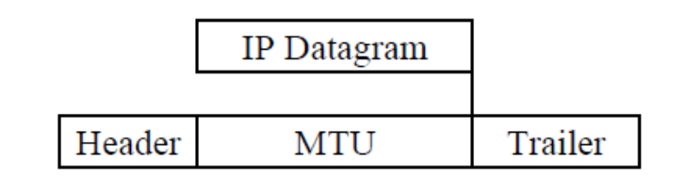

The value of MTU differs from one physical network to another In order to make IP protocol portable/independent of the physical network, the packagers decided to make the maximum length of the IP datagram equal to the largest Maximum Transfer Unit (MTU) defined so far. However for other physical networks we must divide the datagrams to make it possible to pass through these networks. This is called fragmentation. When a datagram is fragmented, each fragmented has its own header. A fragmented datagram may itself be fragmented if it encounters a network with an even smaller MTU. In another words, a datagram may be fragmented several times before it reached the final destination and also, the datagrams referred to as (frames in Data link layer) may arrives out of order at destination. Hence sorting of frames need to be done at the destination to recover the original data.
The following program simulates the frame sorting technique used in buffers.

Algorithm
- Read a message from the keyboard
- Divide the message into fixed size packets. Include sequence number and other information in each packet.
- Shuffle the packets (to generate out of order packets )
- Order the packets based on sequence numbers
- Display the ordered packets.

/**************************************************************************
* File Name : FrameSort.c
*
* Description : A program for frame sorting technique used in buffers
***************************************************************************/

#include <stdlib.h>
#include <stdio.h>
#include <string.h>
#include <time.h>

#define DATA_SZ 3

typedef struct packet
{
int SeqNum;
char Data[DATA_SZ+1];
}PACKET;

PACKET *readdata, *transdata;
time_t t ;

// Breaks the message into packets
int divide(char *msg)
{
int msglen, NoOfPacket, i, j;
msglen = strlen(msg);
NoOfPacket = msglen/DATA_SZ;

if((msglen%DATA_SZ)!=0)
NoOfPacket++;

readdata = (PACKET *)malloc(sizeof(PACKET) *NoOfPacket);
for(i = 0; i < NoOfPacket; i++)
{
readdata[i].SeqNum = i + 1;
for (j = 0; (j < DATA_SZ) && (*msg != '\0'); j++, msg++)
readdata[i].Data[j] = *msg;
readdata[i].Data[j] = '\0';
}

printf("\nThe Message has been divided as follows\n");
printf("\nPacket No.\tData\n\n");
for (i = 0; i < NoOfPacket; i++)
printf(" %d\t\t%s\n", readdata[i].SeqNum, readdata[i].Data);

return NoOfPacket;
}

// shuffles the packets
void shuffle(int NoOfPacket)
{
int *Status;
int i, j, trans;

srand(time(&t)); //every time you shuffle,get different random sequence
Status=(int * )calloc(NoOfPacket, sizeof(int));
transdata = (PACKET *)malloc(sizeof(PACKET) * NoOfPacket);

for (i = 0; i < NoOfPacket;)
{
trans = rand()%NoOfPacket;
if (Status[trans]!=1)
{
transdata[i].SeqNum = readdata[trans].SeqNum;
strcpy(transdata[i].Data, readdata[trans].Data);
i++;
Status[trans] = 1;
}
}

free(Status);
}

// sorts the packets
void sortframes(int NoOfPacket)
{
PACKET temp;
int i, j;

for (i = 0; i < NoOfPacket; i++)
{
for (j = 0; j < NoOfPacket - (i+1); j++)
{
if (transdata[j].SeqNum > transdata[j + 1].SeqNum)
{
temp.SeqNum = transdata[j].SeqNum;
strcpy(temp.Data, transdata[j].Data);
transdata[j].SeqNum = transdata[j + 1].SeqNum;
strcpy(transdata[j].Data, transdata[j + 1].Data);
transdata[j + 1].SeqNum = temp.SeqNum;
strcpy(transdata[j + 1].Data, temp.Data);
}
}
}
}

// receives packets out of order and calls sort function
void receive(int NoOfPacket)
{
int i;
printf("\nPackets received in the following order\n");
for (i = 0; i < NoOfPacket; i++)
printf("%4d",transdata[i].SeqNum);

sortframes(NoOfPacket);

printf("\n\nPackets in order after sorting..\n");
for (i = 0; i < NoOfPacket; i++)
printf("%4d",transdata[i].SeqNum);
printf("\n\nMessage received is :\n");
for (i = 0; i < NoOfPacket; i++)
printf("%s",transdata[i].Data);
}

int main()
{
char msg[25];
int NoOfPacket;
printf("\nEnter The message to be Transmitted :\n");
scanf("%[^\n]", msg);
NoOfPacket = divide(msg);
shuffle(NoOfPacket);
receive(NoOfPacket);
free(readdata);
free(transdata);
return 0;
}

Experiment No. 3
Problem Statement:
Write a program for Distance Vector Algorithm to find suitable path for transmission.

Theory:
The distance vector routing algorithm is sometimes called by other names, including the distributed Bellman-Ford routing algorithm and the Ford-Fulkerson algorithm, after the researchers who developed it. In distance vector routing, each router maintains a routing table indexed by, and containing one entry for, each router in subnet. This entry contains two parts: the preferred out going line to use for that destination, and an estimate of the time or distance to that destination. The metric used might be number of hops, time delay in milliseconds, total number of packets queued along the path, or something similar.

Algorithm:
- Read the initial routing table. The initial routing table for each router consists of the distances to each of its neighbours. Distance is assumed to be infinity if there is no direct path.
- To build the final routing table, each router communicates with each of its neighbours to update the routing table. The basic principle here is as follows:
Consider a node X that is interested in routing to destination Y via its directly attached neighbour Z. Node X's distance table entry, D^{x}(Y,Z) is the sum of the cost of the direct link between X and Z, c(X,Z), plus neighbour Z's currently known minimum cost path from itself (Z) to Y. That is:
D^{x}(Y, Z) = c(X, Z) + min_{w}{D^{z}(Y, w)}
The min_{w} term is taken over all of Z's directly attached neighbours (including X)

/**************************************************************************
* File Name : DistVect.c
*
* Description : A program for distance vector algorithm to find suitable
path for transmission.
***************************************************************************/

#include<stdio.h>

#define INFINITY 999

struct
{
int cost;
int via;
}routeTable[10][10];

int n; //no. of nodes

// function to build DV routing table
void build_route_table(int i)
{
int j,k,new_cost=0;

for(j=0;j<n;j++)
{
for(k=0;k<n && j!=i;k++)
{

// consider only adjacent routers
if(routeTable[i][j].cost != INFINITY)
{
new_cost =routeTable[i][j].cost+routeTable[j][k].cost;
if(routeTable[i][k].cost > new_cost)
{
routeTable[i][k].cost=new_cost;
routeTable[i][k].via=routeTable[i][j].via;
}
}
}
}

}

// function to find shortest path between 2 routers
void find_path(int i,int j)
{
printf("%c",'A' + i);
if(i != j)
{
printf(" --> ");
find_path(routeTable[i][j].via,j);
}
}

// function to display routing table for each router
void disp_route_table(int i)
{
int j;
printf("\nFinal Routing Table for %c: ",'A' + i);
printf("\n\tDestination\tCost\tOutgoing line");
printf("\n\t-------------\t----\t--------------\n");
for(j=0;j<n;j++)
{
printf("\n\t\t%c",'A' + j);
printf("\t%d",routeTable[i][j].cost);
printf("\t%c",'A' + routeTable[i][j].via);
printf("\n");
}
}

// function to read initial routing table for each router.
void read_route_table()
{
int i,j;

printf("Enter the initial routing table (if no direct node, enter 999):\n");
for(i=0;i<n;i++)
{
printf("\nRouting table for %c:\n",'A' + i);
for(j=0;j<n;j++)
{
if(i==j)
routeTable[i][j].cost=0;
else
{
printf("--> %c:",'A' + j);
scanf("%d",&routeTable[i][j].cost);
}
if(routeTable[i][j].cost != INFINITY)
routeTable[i][j].via=j;
else
routeTable[i][j].via=INFINITY;
}
}
}

// main function

int main()
{
int src,dst,i;
int opt;

printf("Enter the Number of routers:");
scanf("%d",&n);

//read initial routing table
read_route_table();

//build the routing table
for(i=0;i<n;i++)
build_route_table(i);

//display the final routing table
for(i=0;i<n;i++)
disp_route_table(i);

do
{
printf("\nEnter the Source node(0 to %d): ",n-1);
scanf("%d",&src);
printf("Enter the Destination node(0 to %d):",n-1);
scanf("%d",&dst);

if(src > (n - 1) || dst > (n - 1))
printf("\n router doest not exist");
else
{
find_path(src,dst);
printf("\nThe cost of the shortest route is:\t%d\n",routeTable[src][dst].cost);
}

printf("\nDo you want to continue? (0/1):\n");
scanf("%d",&opt);
}while(opt);

return 0;
}

Experiment No. 4
Problem Statement:
Using TCP sockets, write a client-server program to make client sending the file name and the
server to send back the contents of the requested file if present.

Theory:
A socket allows an application to "plug in" to the network and communicate with other applications that are also plugged in to the same network. Information written to the socket by an application on one machine can be read by an application on a different machine, and vice versa. Sockets come in different flavors, corresponding to different underlying protocol families and different stacks of protocols within a family. we deal only with the TCP/IP protocol family. The main flavors of sockets in the TCP/IP family are stream sockets and datagram sockets. Stream sockets use TCP as the end-to-end protocol (with IP underneath) and thus provide a reliable byte-stream service. Datagram sockets use UDP (again, with IP underneath) and thus provide a best-effort datagram service that applications can use to send individual messages up to about 65,500 bytes in length.
A socket using the TCP/IP protocol family is uniquely identified by an Internet address, an end-to-end protocol (TCP or UDP), and a port number. When a socket is first created, it has an associated protocol but no Internet address or port number. Until a socket is bound to a port number, it cannot receive messages from a remote application.

Sockets, protocols, and ports.

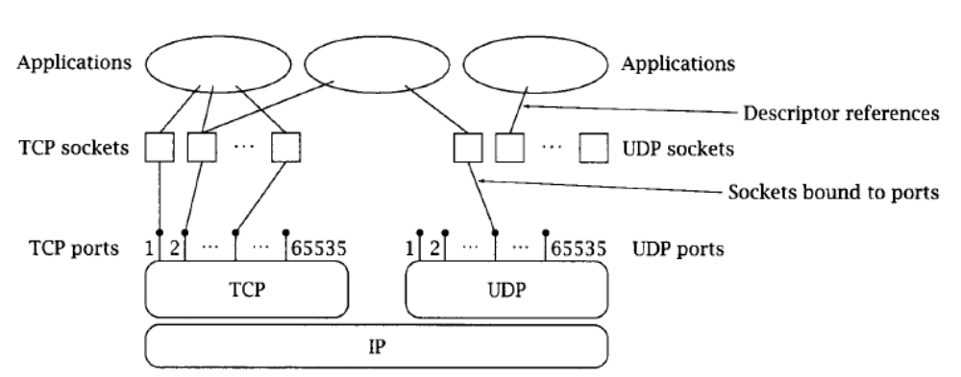

Algorithm (Client Side)
1. Start.
2. Create a socket using socket () system call.
3. Connect the socket to the address of the server using connect () system call.
4. Send the filename of required file using send () system call.
5. Read the contents of the file sent by server by recv () system call.
6. Stop.
Algorithm (Server Side)
1. Start.
2. Create a socket using socket () system call.
3. Bind the socket to an address using bind () system call.
4. Listen to the connection using listen () system call.
5. Accept connection using accept ()
6. Receive filename and transfer contents of file with client.
7. Stop.

Client/Server communication using TCP socket:
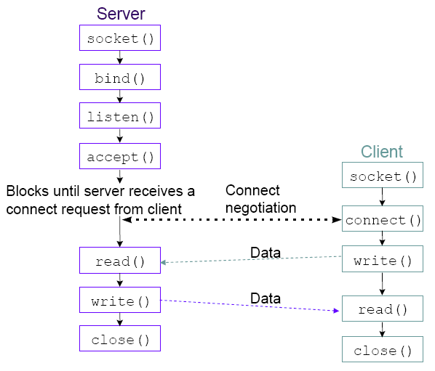

/**************************************************************************
* File Name : tcpClient.c
*
* Description : TCP Client program
***************************************************************************/

#include<stdio.h>
#include<netdb.h>
#include<sys/types.h>
#include<sys/socket.h>
#include<netinet/in.h>
#include<stdlib.h>
#include<string.h>

#define BUF_SIZE 500
#define PORT 3500

int main(int argc, char **argv)
{
int n,sd;
struct hostent *hp;
struct sockaddr_in server;
char *host, rbuf[BUF_SIZE], sbuf[BUF_SIZE];

if (argc==2)
host = argv[1];
else
{
fprintf(stderr, "usage: client host\n");
exit(1);
}

/* translate host name into peer's IP address */
hp = gethostbyname(host);
if (!hp)
{
fprintf(stderr, "Client: unknown host: %s\n", host);
exit(1);
}

/* build address data structure */
bzero((char *)&server,sizeof(struct sockaddr_in));
bcopy(hp->h_addr,(char *)&server.sin_addr,hp->h_length);
server.sin_family=AF_INET;
server.sin_port=htons(PORT);

/* create client socket */
if ((sd = socket(AF_INET,SOCK_STREAM,0)) < 0)
{
perror("Client: socket Error");
exit(1);
}
if (connect(sd,(struct sockaddr *)&server,sizeof(server)) < 0)
{
perror("Client: connect Error");
close(sd);
exit(1);
}

printf("Enter the file name (type stop to close the SERVER) :\n");
scanf("%s",sbuf);

write(sd,sbuf,BUF_SIZE);
printf("Content of the file: \n");
while(n=read(sd,rbuf,BUF_SIZE)>0)
printf("%s",rbuf);
close(sd);
return(0);
}

/**************************************************************************
* File Name : tcpServer.c
*
* Description : Server program using tcp sockets to transfer the contents of
the requested file
***************************************************************************/

#include<stdio.h>
#include<sys/types.h>
#include<sys/socket.h>
#include<netinet/in.h>
#include<string.h>
#include<stdlib.h>
#include<fcntl.h>

#define BUF_SIZE 500
#define PORT 3500

int main()
{
int fd; // file descriptor
int sd,new_sd; // socket descriptors
int client_len;
struct sockaddr_in server,client;
char n,rbuf[BUF_SIZE],buf[BUF_SIZE]; // buffer variables

/* build address data structure */

bzero((char *)&server,sizeof(struct sockaddr_in));
server.sin_family=AF_INET;
server.sin_port=htons(PORT);
server.sin_addr.s_addr=htonl(INADDR_ANY);

/* create server socket */
if ((sd = socket(AF_INET,SOCK_STREAM,0)) < 0)
{
perror("Server : socket error");
exit(1);
}

if ((bind(sd,(struct sockaddr *)&server,sizeof(server))) < 0)
{
perror("Server : bind error");
exit(1);
}

// listen to the incoming connections
listen(sd,5);

while(1)
{
client_len=sizeof(client);
printf("Waiting for connection...\n");
if ((new_sd = accept(sd,(struct sockaddr *)&client,&client_len))< 0)
{
perror("Server : accept error");
exit(1);
}
printf("Connected...\n");
n=read(new_sd,buf,BUF_SIZE);
if(strcmp(buf,"stop") == 0)
{
printf("Server is closed");
break;
}
fd=open(buf,O_RDONLY);
if(fd == -1)
printf("File %s does not exists\n",buf);
else
{
while(n=read(fd,rbuf,BUF_SIZE)>0)
{
write(new_sd,rbuf,BUF_SIZE);
}
printf("File %s content sent...\n",buf);
}
close(new_sd);
close(fd);
}
close(sd);
return(0);
}

Experiment No. 5
Problem Statement:
Using UDP SOCKETS, write a client-server program to make the client sending two numbers and an operator, and server responding with the result. Display the result and appropriate messages for invalid inputs at the client side.
Theory: Refer to the Experiment No. 4
Algorithm (Client Side)
1. Start.
2. Create a socket using socket () system call.
3. Connect the socket to the address of the server using connect () system call.
4. Read two numbers and an operator, and them using sendto () system call.
5. Receive the result sent by server using recvfrom () system call.
6. Stop.
Algorithm (Server Side)
1. Start.
2. Create a socket using socket () system call.
3. Bind the socket to an address using bind () system call.
4. Listen to the connection using listen () system call.
5. Accept connection using accept ()
6. Receive the numbers and operator. Send the result to the client.
7. Stop.
Client/Server communication using TCP socket
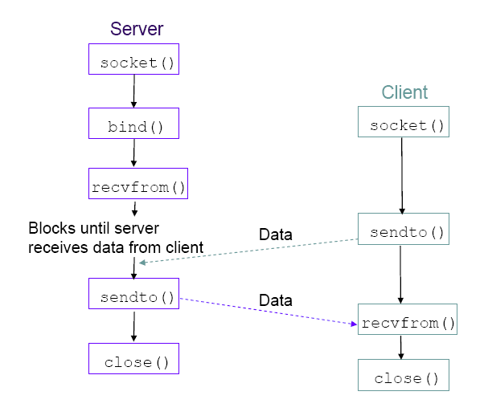

/**************************************************************************
* File Name : udpClient.c
*
* Description : UDP Client
***************************************************************************/

#include <stdio.h>
#include <stdio_ext.h>
#include <string.h>
#include <sys/time.h>
#include <netdb.h>
#include <sys/types.h>
#include <sys/socket.h>
#include <netinet/in.h>
#include <stdlib.h>
#include <string.h>

#define SERVER_UDP_PORT 5003 /* UDP port*/
#define MAXLEN 64 /* maximum data length */

int main(int argc, char **argv)
{

struct hostent *hp;
struct sockaddr_in server, client;

int data_size = MAXLEN, port = SERVER_UDP_PORT;
int sd, server_len;
char *pname, *host, rbuf[MAXLEN], sbuf[MAXLEN],ch;

int i, j;
int opt =1;
float n1,n2;
char op;

pname = argv[0];
argc--;
argv++;
if (argc > 0)
{
host = *argv;
if (--argc > 0)
port = atoi(*++argv); // port number
}

else
{
// must specify server address

fprintf(stderr,"Usage: %s [-s data_size] host [port]\n", pname);
exit(1);
}

/* Create a datagram socket */
if ((sd = socket(AF_INET, SOCK_DGRAM, 0)) == -1)
{
fprintf(stderr, "Can't create a socket\n");
exit(1);
}

/* Store server's information */
bzero((char *)&server, sizeof(server));
server.sin_family = AF_INET;
server.sin_port = htons(port);

if ((hp = gethostbyname(host)) == NULL)
{
fprintf(stderr,"Can't get server's IP address\n");
exit(1);
}

bcopy(hp->h_addr, (char *)&server.sin_addr,hp->h_length);

/* Bind local address to the socket */
bzero((char *)&client, sizeof(client)); // initalise client address
client.sin_family = AF_INET; // asign address family
client.sin_port = htons(0); // assign port
client.sin_addr.s_addr = htonl(INADDR_ANY); // assign any port

if (bind(sd, (struct sockaddr *)&client,sizeof(client)) == -1)
{
fprintf(stderr, "Can't bind name to socket\n");
close(sd);
exit(1);
}
printf(" \n Connected to the server : ");

server_len = sizeof(server);

while(opt == 1)
{
printf("\n Enter operator(+,-,/,*):");
scanf("%c",&op);
printf("\n Enter first number:");
scanf("%f", &n1);
printf("\n Enter second number:");
scanf("%f", &n2);
sprintf (sbuf, "%f%c%f", n1,op, n2);

/* send the parameters */
if (sendto(sd, sbuf, data_size, 0, (struct sockaddr *)&server, server_len) == -1)
{
fprintf(stderr, "\n sendto error\n");
close(sd);
exit(1);
}

/* receive the result */
` if (recvfrom(sd, rbuf, MAXLEN, 0, (struct sockaddr *) &server, &server_len) < 0)
{
fprintf(stderr, "\n recvfrom error\n");
close(sd);
exit(1);
}

printf("\n Result : %s", rbuf);
printf("\n Want to continue ? (0/1) :");
scanf("%d",&opt);

setbuf(stdin,NULL); // clear input streams
}

close(sd);
return(0);
}

/**************************************************************************
* File Name : udpServer.c
*
* Description : UDP server to perform arithmetic operarion and send the result.
***************************************************************************/
#include <stdio.h>
#include <sys/types.h>
#include <sys/socket.h>
#include <netinet/in.h>
#include <string.h>
#include <stdlib.h>
#include <math.h>

#define SERVER_UDP_PORT 5003 /* Server port */
#define MAXLEN 64 /* maximum data length */

int main(int argc, char **argv)
{
int sd, client_len, port, n;
char buf[MAXLEN]; /* buffer for storing messages */
struct sockaddr_in server, client;
int dv_flg=0; /* to check for division error */
float n1,n2,res;
char op;

switch(argc)
{
case 1:
port = SERVER_UDP_PORT;
break;
case 2:
port = atoi(argv[1]);
break;
default:
fprintf(stderr, "Usage: %s [port]\n", argv[0]);
exit(1);
}

/* Create a datagram socket */
if ((sd = socket(AF_INET, SOCK_DGRAM, 0)) == -1)
{
fprintf(stderr, "Can't create a socket\n");
exit(1);
}

/* Bind an address to the socket */
bzero((char *)&server, sizeof(server));/* fill the structure with zeros*/
server.sin_family = AF_INET; /* assign address family */
server.sin_port = htons(port); /* assign port */
server.sin_addr.s_addr = htonl(INADDR_ANY); /* any IP address */

if (bind(sd, (struct sockaddr *)&server,sizeof(server)) == -1)
{
fprintf(stderr, "Can't bind name to socket\n");
close(sd);
exit(1);
}

printf("waiting .. .");
client_len = sizeof(client);
while (1)
{
dv_flg=0;

/* Recieve first number */
if ((n = recvfrom(sd, buf, MAXLEN, 0,(struct sockaddr *)&client, &client_len)) < 0)
{
fprintf(stderr, "Can't receive datagram\n");
close(sd);
exit(1);
}

/* Extract the parameters */
sscanf (buf,"%f%c%f",&n1,&op,&n2);
if(op == '+')
res = n1 + n2;
if(op == '-')
res = n1 - n2;
if(op == '*')
res = n1 * n2;
if(op == '/')
{
if (n2==0)
dv_flg =1;
else
res = n1 / n2;
}
if(dv_flg == 1) /* division error */
strcpy(buf,"Divison error");
else
sprintf (buf, "%f", res);

if (sendto(sd, buf, n, 0,(struct sockaddr *)&client, client_len) < 0 ) /* send datagram */
{
fprintf(stderr, "Can't send datagram\n");
close(sd);
exit(1);
}
}
close(sd);
return(0);
}

Experiment No. 6
Problem Statement:
Write a program for Hamming Code generation for error detection and correction
Theory:
Hamming codes (Richard Hamming, 1950) are used for detecting and correcting single bit errors in transmitted data. This requires that 3 parity bits (check bits) be transmitted with every 4 data bits. The algorithm is called A(7, 4) code, because it requires seven bits to encode 4 bits of data.
Algorithm (encoding)
- Index (k+ r) bits starting from 1. E.g . bit 1, 2, 3, 4, 5, etc.
- Write the bit position numbers in binary. i.e. 1, 10, 11, 100, 101, etc.
- All bit positions that are powers of two are parity bits.
- All other bit positions are data bits.
- Each data bit is included in a unique set of 2 or more parity bits, as determined by the binary form of its bit position.

Bit position |  | 01 | 10 | 11 | 100 | 101 | 110 | 111 | 1000 | 1001 | 1010 | 1011 | 1100 | 1101 | 1010 | 1111 | 10000 | 10001 | 10010 | 10011 | 10100
 |  | 1 | 2 | 3 | 4 | 5 | 6 | 7 | 8 | 9 | 10 | 11 | 12 | 13 | 14 | 15 | 16 | 17 | 18 | 19 | 20 | ...
Encoded data bits |  | p1 | p2 | d1 | p4 | d2 | d3 | d4 | p8 | d5 | d6 | d7 | d8 | d9 | d10 | d11 | p16 | d12 | d13 | d14 | d15 | ...
Parity  bit  coverage | p1 | X |  | X |  | X |  | X |  | X |  | X |  | X |  | X |  | X |  | X |  | ...
Parity  bit  coverage | p2 |  | X | X |  |  | X | X |  |  | X | X |  |  | X | X |  |  | X | X |  | ...
Parity  bit  coverage | p4 |  |  |  | X | X | X | X |  |  |  |  | X | X | X | X |  |  |  |  | X | ...
Parity  bit  coverage | p8 |  |  |  |  |  |  |  | X | X | X | X | X | X | X | X |  |  |  |  |  | ...
Parity  bit  coverage | p16 |  |  |  |  |  |  |  |  |  |  |  |  |  |  |  | X | X | X | X | X | ...

Algorithm (decoding)
- To check for errors, check all of the parity bits. If all parity bits are correct, there is no error.
- Otherwise, the sum of the positions of the erroneous parity bits identifies the erroneous bit.
- If only one parity bit indicates an error, the parity bit itself is in error. Erroneous parity bit means no. of one 1’s is odd. Correct parity bit means no. of one 1’s is even.
- Extract the data bits if there is no error.

/**************************************************************************
* File Name : HamCode.c
*
* Description : Hamming Code generation for error detection and correction.
***************************************************************************/

#include<stdio.h>

#define MAX_SZ 50

int data[MAX_SZ],temp[MAX_SZ];

// finds 2^n
int power(int n)
{
int i,p=1;
for(i=1;i<=n;i++)
{
p=p*2;
}
return(p);
}

// computes parity bits, k= no. of data bits,r=no. of parity bits.
int find_parity_bits(int k, int r)
{
int n,i,j;
int err_sum = 0,cnt_ones;
n = j = 1;
while(n < power(r))
{
i=n;
cnt_ones=0;
while(i<=(k+r))
{
for(j=0;j<n;j++)
{
if(temp[i+j]==1)
cnt_ones++;
}
i=i+2*n;
}
if((cnt_ones%2)!=0)
{
temp[n]=1;
err_sum += n ;
}
else
temp[n]=0;
n=n*2;
}
return err_sum;
}

//finds hamming code

int hamming_code(int k)
{
int i,j,d=0;
int r = 1; //r = no.of parity bits

while(k > (power(r)-r-1))
r++;

j = k;
for(i=1;i<=(k+r);i++)
{
if(i==power(d))
{
temp[i]=0;
d++;
}
else
temp[i]=data[j--];
}

return(r);
}

int check_err(int err_pos,int r)
{
int i;

for(i=1;i < power(r) ; i = i * 2)
{
if(err_pos == i)
{
return 1;
}
}
return 0;
}

int main()
{

int k,r;
int err_pos,i;

printf("no of databits\n");
scanf("%d",&k);
printf("enter the data to be transmitted(0's & 1's)\n");
for(i=1;i<=k;i++)
scanf("%d",&data[i]);

r = hamming_code(k); // find hamming code
printf ("\nNo. of parity bits r = %d",r);
find_parity_bits(k,r);

printf("\n\nHamming code for the data:\n");
for(i=1;i<=(k+r);i++)
printf("%4d",temp[i]);

// error detection and correction
printf("\n\nenter the recieved data:\n");
for (i=1; i <= k+r; i++)
scanf("%d", &temp[i]);

err_pos = find_parity_bits(k,r);

if (err_pos != 0)
{
if(check_err(err_pos,r))
printf("\n\nParity bit P%d is corrupted, data is fine", err_pos);
else
{
printf("\n\nData bit D%d is corrupted. ", err_pos);
// flip the error bit
temp[err_pos] = !(temp[err_pos]);
printf("\n\nCorrected data bits with new parity bits\n");
for(i=1;i<=(k+r);i++)
printf("%4d",temp[i]);
}
}
else
printf("No error");
return 0;
}

Experiment No. 7
Problem Statement:
Write a program for simple RSA algorithm to encrypt and decrypt the data.

Theory:
The RSA algorithm is named after Ron Rivest, Adi Shamir and Len Adleman, who invented it in 1977.The RSA algorithm can be used for both public key encryption and digital signatures. Its security is based on the difficulty of factoring large integers.

Algorithm (computing public key and the private key)
- Choose two large prime numbers, p and q
- Compute n = p x q and z = (p - 1) x (q - 1).
- Choose a number that is relatively prime to z and call it e
i.e. gcd (z, e) =1
- Find d such that e x d = 1 mod z.
Public key = {e, n} and private key = {d, n}.

Algorithm (encryption and decryption)
Let P be plaintext (an Integer) to be encrypted, 0 ≤ P ≤n
- To encrypt compute C = P^{e} (mod n)
- To decrypt C, compute P = C^{d} (mod n).
RSA is based on the following key property:
P^{de} (mod n) = P (mod n)
Modular arithmetic involving large numbers can be simplified by using the following property.
(ab) mod n = ((a mod n )(b mod n )) mod

/**************************************************************************
* File Name : RSA.c
*
* Description : Simple RSA algorithm to encrypt and decrypt the data.
***************************************************************************/

#include "stdafx.h"

#include<stdio.h>
#include<math.h>
#include<string.h>

#define MAX_SZ 100

unsigned int min(unsigned int x, unsigned int y)
{
return(x<y?x:y);
}

unsigned int max(unsigned int x, unsigned int y)
{
return(x>y?x:y);
}

unsigned int gcd(unsigned int x, unsigned int y)
{
if(x==y)
return(x);
else
return(gcd(min(x,y),max(x,y)-min(x,y)));
}

unsigned int xpowy_modn(unsigned int x,unsigned int y, unsigned int n)
{
unsigned int r=1;
while(y>0)
{
if((int)(y%2)==1)
r=(r*x)%n;
x=(x*x)%n;
y=y/2;
}
return(r);
}

unsigned int find_encrypt_key(unsigned int z)
{
unsigned int e;
do
{
printf("\n Enter a number e that is relatively prime to z and < z:");
scanf("%d",&e);
if(e>=z)
continue;
}while(gcd(e,z)!=1);

return(e);
}

unsigned int find_decrypt_key(unsigned int e,unsigned int z)
{
unsigned int d;
for(d=2;d<z;++d)
{
if(((long int)(e*d)%(long int)z)==1)
break;
}
return(d);
}

int main()
{
//long double
unsigned int plain_txt[MAX_SZ], cipher_txt[MAX_SZ];
unsigned int p,q,z,n,e,d;
char msg[MAX_SZ];
int i;

read:
do
{
printf("\n Enter two large prime numbers p and q:");
scanf("%d%d",&p,&q);
}while(p==q);
n=p*q;
z=(p-1)*(q-1);

printf("\n n=%d,z=%d",n,z);
if(n < 120)
{
printf("\n\nPlease keep n >= 122");
goto read;
}

e=find_encrypt_key(z);
d=find_decrypt_key(e,z);

printf("\nPublic key ={%d,%d}",e,n);
printf("\nPrivate key ={%d,%d}",d,n);

printf("\nEnter a string consisting only letters(a-zA-Z) :");
scanf("%s", msg);

for(i=0;i<strlen(msg);i++)
{
plain_txt[i]=msg[i];
printf("\n%c = %d:",plain_txt[i],plain_txt[i]);
}

// find cipher text
printf("\n\nCipher Text:\n");
for(i=0; i<strlen(msg); i++)
{
cipher_txt[i] = xpowy_modn(plain_txt[i], e,n);
printf("\n%d=%c",cipher_txt[i],cipher_txt[i]);
}
printf("\n\nPlain Text:\n ");
for(i=0; i<strlen(msg); i++)
{
plain_txt[i] = xpowy_modn(cipher_txt[i],d,n);
printf("\n%c = %d",plain_txt[i],plain_txt[i]);
}

return(0);
}

Experiment No. 8
Problem Statement:
Write a program for congestion control using Leaky bucket algorithm.
Theory:
Leaky bucket (proposed by Jonathan S. Turner, 1986) is a traffic shaping algorithm. Each host is connected to the network by an interface containing a leaky bucket, that is, a finite internal queue. If a packet arrives at the queue when it is full, the packet is discarded. In other words, if one or more process are already queued, the new packet is unceremoniously discarded.
The host is allowed to put one packet per clock tick onto the network. This mechanism turns an uneven flow of packet from the user process inside the host into an even flow of packet onto the network, smoothing out bursts and greatly reducing the chances of congestion.

Algorithm
- The leaky bucket consists of a finite queue.
- When a packet arrives, if there is room on the queue it is appended to the queue; otherwise, it is discarded.
- At every clock tick, one packet is transmitted

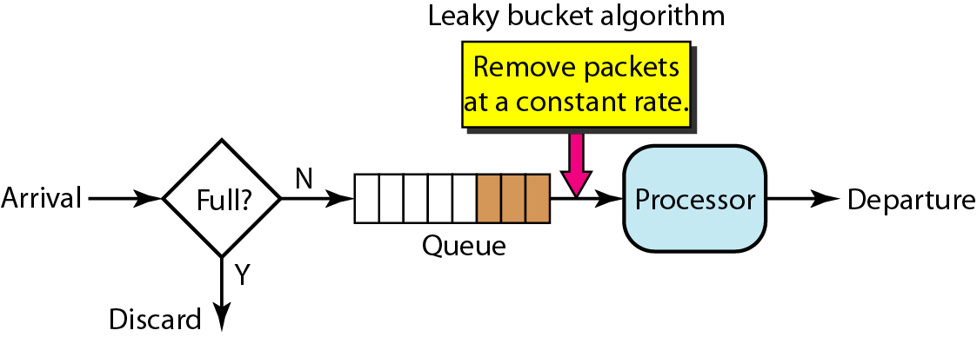

/**************************************************************************
* File Name : LeakyBucket.c
*
* Description : A program to implement Leaky Bucket Algorithm
***************************************************************************/
#include "stdafx.h"

#include<stdio.h>
#include<stdlib.h>
#define BUCKETSIZE 250
#define OUTRATE 25

struct
{
int arrtime;
int weight;

}packet[15];

void read_packets(int n)
{
int i;
for(i=0;i<n;i++)
{
printf("Enter arrival time:");
scanf("%d",&packet[i].arrtime);
printf("Enter the packet size:");
scanf("%d",&packet[i].weight);
}
}

// leaky bucket algorithm
void lky_buckNextet()
{
int excess=BUCKETSIZE;
int i,j=0,rem=0;

// receive packets for 30 msec
for(i=0;i<=30;i++)
{
if(packet[j].arrtime==i)
{
if(packet[j].weight<=excess)
{
rem=packet[j].weight+rem;
excess=excess-packet[j].weight;
printf("At time=%d: packet %d inserted into bucket,",i,j+1);
printf(" remaining bucket size= %d\n",excess);
j=j+1;
}
else
{
printf("At time = %d: packet %d discarded,",i,j+1);
printf("Packet size is more than buffer size\n");
j=j+1;
}
}
// send packets every 5 msec
if((i%5)==0)
{
if(rem>=OUTRATE)
{
rem=rem-OUTRATE;
excess=excess+OUTRATE;
printf("At time = %d : 25 Kbytes are transfered ",i);
printf("Free available space in the bucket=%d\n",excess);
}
else if(rem>0)
{
excess=excess+rem;
printf("At time = %d : %d Kbytes are transferred ",i,rem);
printf("Free available space in the bucket=%d\n",excess);
rem=0;
}
}
}//for

// Empty the bucket
while(rem != 0)
{
if(rem < OUTRATE)
{
excess=excess+rem;
printf("At time = %d : %d Kbytes are transfered ",i++,rem);
printf("Free available space in the bucket=%d\n",excess);
break;
}
rem=rem-OUTRATE;
excess=excess + OUTRATE;
printf("At time = %d : %d Kbytes are transfered ",i++,OUTRATE);
printf("Free available space in the bucket=%d\n",excess);
}
printf("Bucket is empty");
}

int main()
{

int n;

printf("Enter the number of packets:");
scanf("%d",&n);

read_packets(n);
lky_bucket();
return 0;
}

